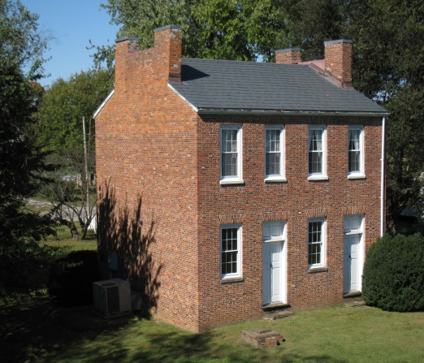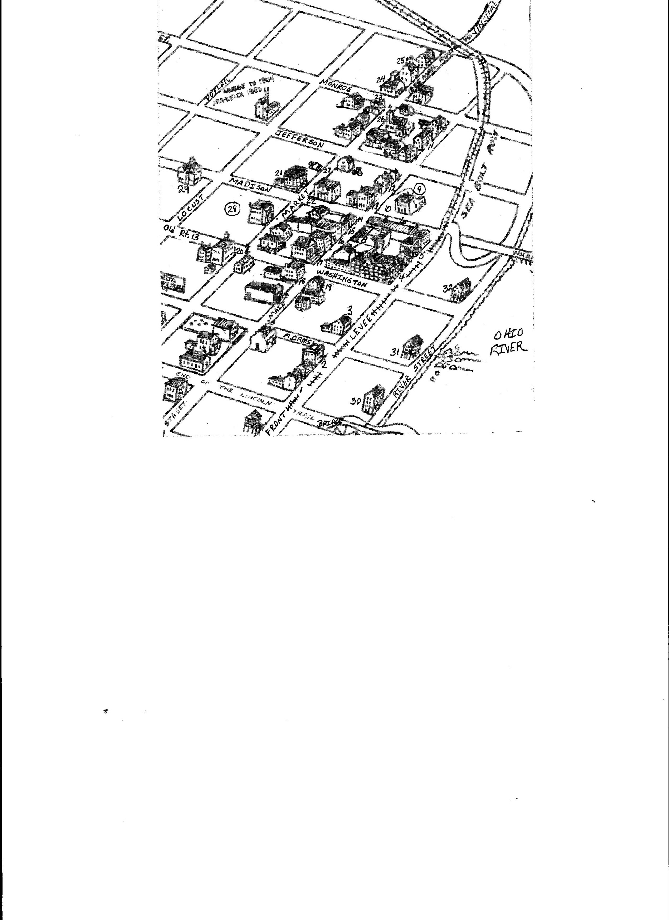

# Hours of Operation

Open May through October

First & Third Sundays – 1pm to 4pm

Other times by appointment

Call 618-269-3531 or 618-518-9355

Located off Route 13 at the Ohio River

Old Shawneetown, IL

A Walking Tour of Historic Old Shawneetown

-Map Inside-

**Historic John Marshall House / Bank / Museum**

Built about 1809

Photos and Design by Christy Short and Cindy Decker 2017

Built during the grandiose days of ‘internal improvements’, with four stories and a five-columned portico. The building was sold during the Civil War to Thomas S. Ridgway for $6,500 when it was feared rebel forces would overrun the town. It has been owned since 1940 by the State of Illinois. **Visitors welcome 1st & 3rd Sundays from May through October – 1p-4p**

GALLATIN COUNTY HISTORICAL SOCIETY ORGANIZED in 1966

John Marshall built the first brick home in Illinois on the banks of the Ohio River which became the 1st Bank in Illinois Territory. This was the birthplace of commercial banking in Illinois. The old building was reconstructed by the Gallatin County Historical Society and opened to the public in 1974.

**St. Mary Catholic Church**

The present church was built in 1931, just six years before the devastating Flood of ’37, now owned by the State of Illinois. The building is located on a former Shawnee Indian Mound. The first Catholic Church was built in 1860 at this site as was the Church Rectory and St. Mary’s school.

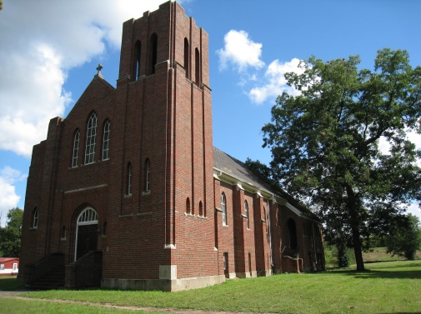

#### First State Bank / Greek Revival Architecture

#### Built 1838-1840 at a cost of $80,000

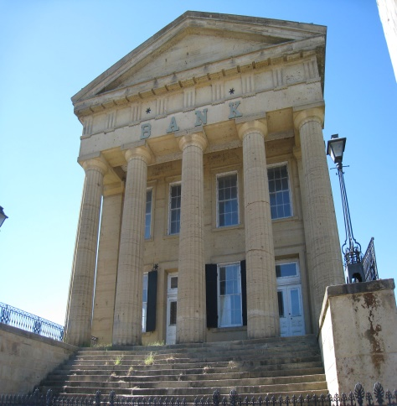

11. Henry Maxwell Peeples House

12. First Henry Eddy home & 1st Newspaper office

13. First Gallatin County Courthouse

14. First U.S. Land Office & Jail in John Caldwell’s home

15. Charles Carroll II Bldg.

16. Gallatin Nat’l Bank/City Nat’l Bank

17. First State Bank - (Five Column Bank)

18. Posey Bldg.

19. Clayton’s Texaco

20. Gallatin County Courthouse & Calaboose

21. A. K Lowe Mansion

22. George Lowe Home / Wm. D. Phile Home

23. James Docker House

24. First Methodist Church

25. Steven Rowan House

26. St. Mary Catholic Church

27. Crane House

28. State Park w/ restrooms

29. Shawneetown Grade & High School

30,31,32. Log Hotels on River Str. - 1814

‘Germania’, Gallatin’, ‘Shawnee House’.

6. John Marshall’s Store & 1st Post Office

7. Nate’s Bar & Grill

8. Original Jones Bldg. / Logsdon Tavern / now Hogdaddy’s

9. Public Restrooms

10. Robert Peeples House

1. John Marshall Home Bank Museum
2. John D. Richeson-Charles Carroll Mansion
3. Gen. John A. Logan married Mary Cunningham
4. Docker’s Riverside Hotel
5. Rawling’s Tavern/Lafayette Hotel