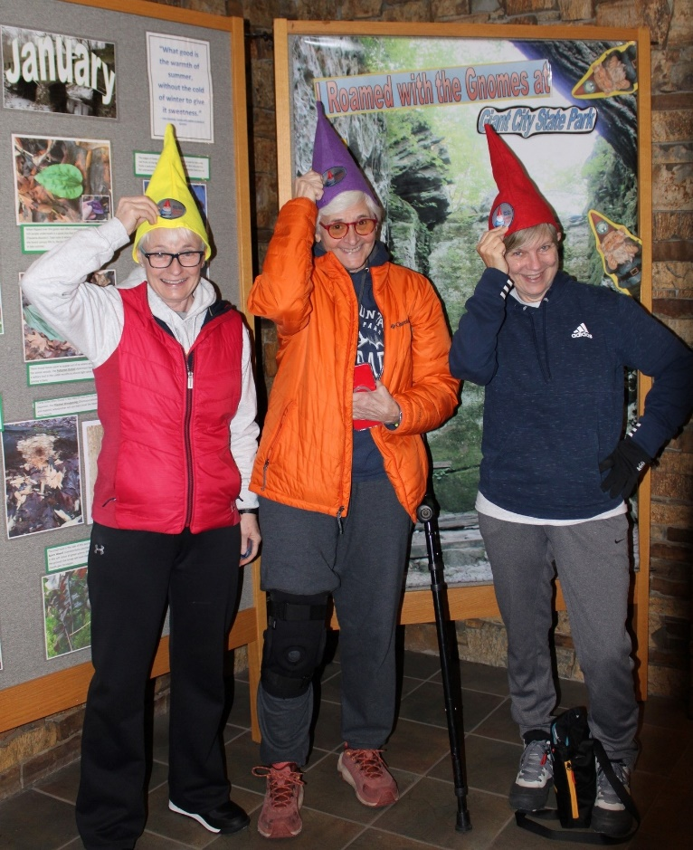
Head for parts Un-Gnome, and Roam for Gnomes on a Winter Adventure at Giant City State Park
Tucked in the stunning Shawnee National Forest, Giant City State Park is a hidden gem offering a unique experience for outdoor enthusiasts, families, and light adventure travelers. One of the park's highlights is the annual wintertime “Gnome Roam”, inviting visitors to explore seven different trails while searching for whimsical winter gnomes scattered along the trails, just waiting to be discovered. The park provides a magical setting for adventure seekers through February when the Gnomes are on the trails.

The Trails
The Gnome Roam meanders through a picturesque landscape of seven well-maintained trails, offering a perfect balance of natural beauty and exploration. These relatively easy trails are accessible to most ages and skill levels. The paths wind through towering trees, sandstone rock formations (the “Giants” of Giant City), and ephemeral creeks, with each twist revealing the park's serene environment.
Winter on the trails can be magical. The sun glistening on icicles and frostflowers, alongside sightings of forest creatures like deer and woodpeckers, creates a striking contrast with the landscape. As you wander, take a moment to pause and soak in the sights and sounds of nature. Listen for the crunch of leaves or snow underfoot and the gentle rustle of branches swaying in the winter breeze. Keep an eye out for a variety of wildlife, making this a perfect outing for nature lovers.
Dress warmly in layers, and don’t forget your phone or camera—the gnomes make fantastic photo ops against the wintry backdrop, and there are even rewards for finding them!


Explore the Gnome Roam on These Trails:
- Giant City Nature Trail: 1 mile
- Devil’s Stand Table Trail: 1/3 mile
- Indian Creek Trail: ¾ mile with a creek
- Arrowwood Trail: ⅓ mile next to the Visitor’s Center
- Post Oak Trail: ⅓ mile with paved access
- Trillium Trail: 2 miles with sandstone bluffs; a more rugged trail
- Stone Fort Trail: ⅓ mile (one of 11 late woodland Indigenous sites in Illinois)

Each of the seven trails has a rosy-cheeked gnome hidden on the trail… and those sneaky guys move around! When visitors find one, they should record the date, trail name, and what the gnome is holding or snap a picture of the gnome… even better, take a selfie with the gnome!
When visitors have completed the trails (over a day or two, or up to three months!), they take their proof (the list or the photos - all seven) to the Giant City Visitor Center for a cool gnome patch. The Visitor Center is open most days from 8 a.m. to 3:30 p.m. (Please note that hours may change around the holidays or for weather issues, so you may need to return to claim your patch, plan accordingly.)
Tips for Hiking in Winter
- Dress in Layers: While the winter here is general mild, winter weather can be unpredictable, so dress in layers to stay comfortable during your hike.
- Check Trail Conditions: Before heading out, check the weather. Winter weather can impact accessibility, be prepared.
- Pack Essentials: Bring water, snacks, and a small first aid kit. Hiking sticks can be helpful for trails that involve a climb. Even on shorter hikes, being prepared for the unexpected is essential.
- Capture the Magic: Be sure to charge your devices—phone or camera—to capture photos with the gnome sculptures along the trails. The trails are open from dawn until dusk, seven days a week.

Gnome Roam Lodging Discount

Save 10% on a 2 night or more stay at select lodging during December through February with the code: GnomeRoam at the following location links: (if no place to enter the code, message the property for the Gnome Roam discount)
- Southern Illinois vacation rentals
- The Dome at Blueberry Hill
- Oak Grove Cabins
- Cabin at Mt. Glen
- Windy Hill Acres Inn
- Rocky Comfort Cabins
- Shawnee Hills Hideaway
Visiting the Gnome Roam at Giant City State Park combines the beauty of nature with a touch of whimsy. From hiking among mesmerizing forests and gnome sculptures to enjoying local culinary delights and cozy accommodations, your winter getaway promises to be filled with adventure and lasting memories. Embrace the spirit of exploration and create your winter tale in this beautiful corner of Southern Illinois. Whether you’re trekking with family or seeking a peaceful retreat, the Gnome Roam is sure to leave you with a smile and cherished memories! Visit: www.southernmostillinois.com

The Wintertime Gnome Roam is back at Giant City State Park, and it’s one of the most unique winter adventures in Southern Illinois. From December 1 – February 28, seven rosy-cheeked gnomes are hiding along seven different trails — and your mission is to find them all!
This self-guided winter hike is perfect for families, couples, and anyone who loves a little magic with their outdoor exploring. Bundle up, snap photos, follow the clues, and roam through sandstone bluffs, peaceful forests, and frosty pathways. When you’ve found all seven gnomes, stop by the Visitor Center to claim your exclusive Gnome Roam patch!

Here’s what to expect:
• 🥾 Seven unique trails (⅓ mile to 2 miles)
• 🎒 A fun, self-paced scavenger hunt
• 📸 Gnomes that move around throughout the season
• 🎁 Earn a limited-edition patch once you complete the roam
• 🏡 Lodging options nearby with a special 10% off discount (code: GNOMEROAM)

Make it a winter day trip — or plan a cozy weekend getaway — and come experience a little woodland whimsy this season.

📅 December 1 – February 28
📍 Giant City State Park, Makanda, Illinois
👉 Full details: southernmostillinois.com/roam-for-gnomes-at-giant-city-state-park/

