Trail of Tears southern Illinois (prepared by Kayeleigh Sharp and Heather Carey):

National Website: <http://www.nationaltota.com/>

Illinois Chapter Website: <http://www.illinoistrailoftears.org/>

Like us on Facebook: Trail of Tears Association, Illinois Chapter

Main Page – Large images (1920x1080) and official Illinois Chapter text provided

Image: Main - OldGolcondaRd(1920x1080).jpg or Alt Main_Camp Ground Church (1920x1080).jpg or Alt Main_Syllabary - (1920x1080).jpg

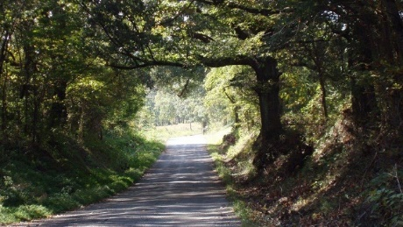 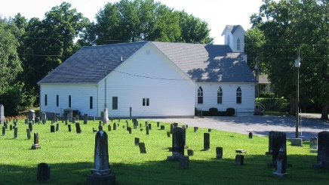 

The Trail of Tears through Illinois

As part of The Indian Removal Act of 1830, eleven Cherokee detachments left their homelands during the fall of 1838 and set out toward Oklahoma territory along what is now referred to as the Northern Route of the Trail of Tears. Part of this route included a nearly sixty-mile (96 km) trek across southern Illinois along the Golconda-Cape Girardeau Trace, from the Ohio River at Golconda to the Mississippi River west of present day Ware, Illinois. The eleven detachments taking this overland route met with an early and harsh winter and the journey took more than a month for seven of the detachments to traverse. By the end of December 1838, temperatures became cold enough to cause ice to block crossing the Mississippi River for several days. Many of the Cherokee were inadequately clothed, barefoot, and unprepared for such harsh conditions. Reportedly, many Cherokee died waiting nearly a month to cross the Mississippi River and some could not be buried in the frozen ground.

The detachments of Cherokee emigrants crossed the Ohio River from Kentucky to the mouth of Lusk Creek using Berry’s Ferry at the small river town of Golconda in Pope County, Illinois. South and west of Golconda traces of the original route still exist on private property just before the Trail subsequently crosses Miller Creek, winds around bottom land and emerges to join present day Homberg Road just south of Illinois Route 146. The Trail then continues in a westerly direction about a mile until it veers to the right on present day Trail of Tears Road. The Cherokee followed the Old Golconda Road through Old Brownfield and camped at Allen Springs before later heading west to camp just south of Dixon Springs. At this point, the Trail goes through a wooded area for almost a mile where it rejoins present day Grasty Road and continues on to traverse Illinois Route 145 before crossing Sugar Creek on the Crabb/Abbott farm, a segment of the original Trail certified by the National Park Service. From the Crabb/Abbott farm, the Trail crosses Forest Service land and exits Hound Ridge Road 300 yards to the north before turning west to enter Johnson County.

The detachments continued into Johnson County where they turned north to avoid the swamps, and camped near present day Grantsburg on Bay Creek. The detachments then weaved south along what is now Route 146 to the small community of Wartrace. After leaving this area some continued on along the old Golconda and Vienna Road while it is believed at some point in this area two paths were taken but rejoined just to the east of Vienna. As they approached Vienna, camp was made on the McCorkle Creek. It was here that Rev. Daniel Butrick’s group learned of the ice jam on the Mississippi River. The detachments then traveled on past Vienna along the section of road known as the Vienna and Jonesboro Road, very much a part of today’s State Route 146, and went into camp at Dutchman Creek. The weather was very harsh on the travelers and made progress slow. They then proceeded west through the Cache River bottoms to the Buckrun Creek/Pleasant Grove area where they camped for several days before continuing on into present day Union County.

Entering Union County, they passed through Pleasant Grove and Mt. Pleasant to the site of the present-day Camp Ground Church. This was a common campground for travelers and it is likely that many of the detachments stopped and camped here and perhaps buried their dead near an existing small family cemetery. It is estimated that up to 6,000 may have camped at this site waiting to cross the Mississippi River. Other detachments followed Camp Ground Road to Old Saratoga Road, camped about three miles (5 km) west of Jonesboro, and moved eventually to Hamburg Landing where they crossed the Mississippi River to Bainbridge, Missouri. Most detachments went slightly north of the Old Hamburg Road to camp along Dutch Creek on the Morgan Farm and later proceeded to Willard’s Landing where they crossed the Mississippi River to Moccasin Springs, Missouri. While most detachments crossed at Willard’s Landing, at least two crossed at New Hamburg to Bainbridge. These ferries were either horse-drawn ferry boats or the less expensive current flatboats operated by ropes strung across the river and could only carry a few people at a time; therefore, it took several days for a detachment to cross the river, even if the weather cooperated.

Gallery – Small Images (1170) and blurbs provided:

Images: Marked Segments - gallery (1170).jpg and TOT_Hwy 146 sign_gallery (1170).jpg

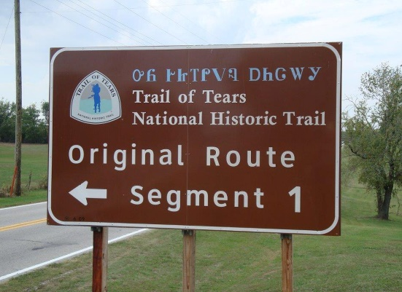 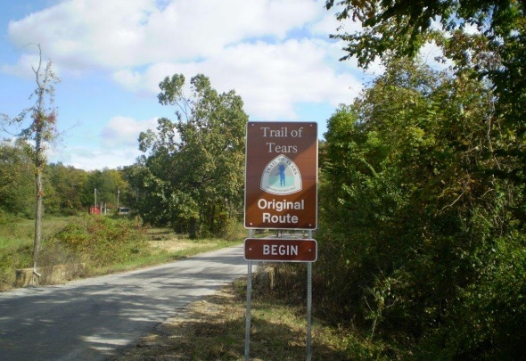

The Auto Tour Route along historic Illinois Route 146 follows the approximate route of the original Trail of Tears for about sixty miles across southern Illinois. Look for official signage that marks segments of the trail in Pope, Johnson and Union counties.

Images: TOT_OhioRiverFerryCrossing_Golconda - gallery (1170).jpg

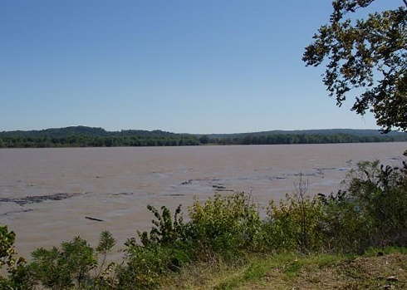

Along the Ohio River, at Golconda, IL, the Cherokee crossed into southern Illinois from Kentucky along their Trail of Tears.

Images: Camp Ground Cemetery sign - gallery (1170).jpg and Camp Ground Cemetery interpretive sign - gallery (1170).jpg

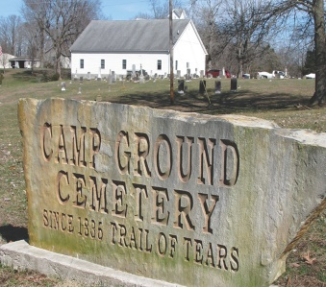 

A number of important locations, such as the Camp Ground Cemetery have recently been added to the National Register of Historic Places and display interpretive signage for visitors.

Images: TrailCut_gallery (1170).jpg and TrailCut2_gallery (1170).jpg

 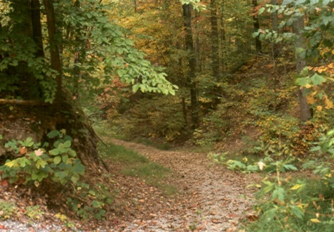

The Trail of Tears through southern Illinois stretches nearly sixty miles long. Original route segments exist as State Highway 146, lesser traveled county roads, and abandoned road cuts that run through forested areas, including parts of the Shawnee National Forest. Many of the segments located on public lands are accessible by car or on foot. Ongoing efforts are focused on protecting and preserving the valuable segments of the Trail of Tears in southern Illinois.

Image: Bus_tour - gallery (1170).jpg and Campground Church-Cherokee Riders 2016 - gallery (1170).jpg and R-R-Riders2017 - gallery (1170).jpg

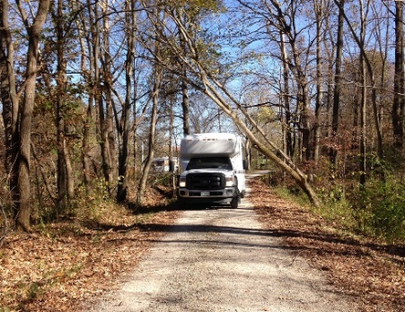 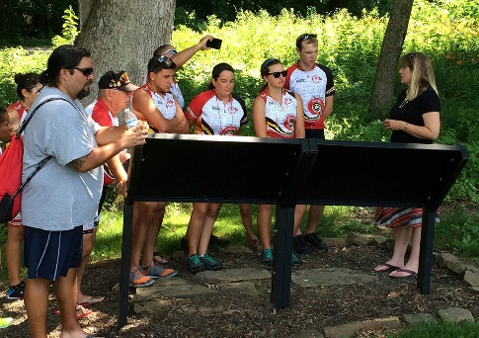 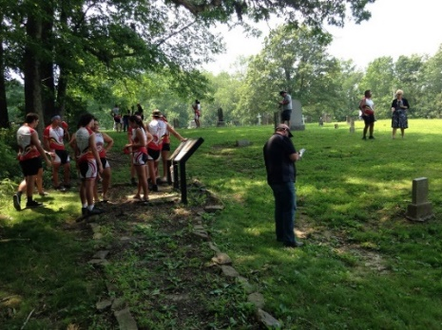

Each year the Illinois Chapter of the Trail of Tears Association hosts a number of events. These include occasional bus tours from Golconda to Jonesboro, IL, as well as visitors such as the Remember the Removal bicycle riders who pay homage to their ancestors that were part of the Indian Removal of 1838-39.

Image: OldMississippiRiverFerryLanding_WillardsFerry - gallery (1170).jpg and WillardsFerryRd_gallery (1170).jpg and WoodCut_FerryDepiction - gallery (1170).jpg

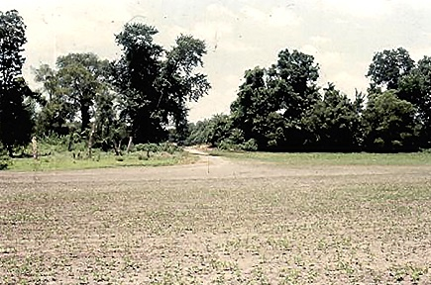  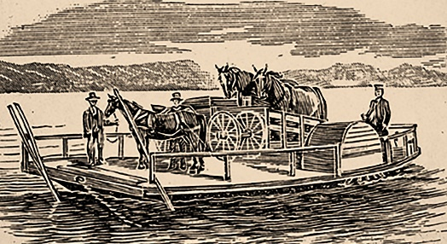

Today, little to nothing remains of the two Mississippi River ferry landings used by the Cherokee in 1838-39. Most detachments left Jonesboro and proceeded to Willard’s Landing where they crossed the river into Moccasin Springs, Missouri, now the site of Trails of Tears State Park. The remaining detachments traveled along Old Hamburg Road to Hamburg Landing, situated across from Bainbridge, Missouri.

Image: touch_the_trail_close - gallery (1170).jpg

